**Description: Publish a sample Store Landing Page with basic product tiles**

(ex. <https://store.hp.com/app/slp/weekly-deals/top-deals>)

* Open book
* No time limit (recommend 4 to 8 hours)
* Feel free to use any styling library for basic styling
* Build the app with listing products using the test-data.json. You don’t have to use the whole entire file, you can short the number of products to 40-50.
* On the first visit, the user should see the login form, where he can type his name and submit this form (no validation needed).
* After submitting the login form, user's name should appear on the navbar with something like "Welcome, %userName%" and take the user to the main page.
* The main listing page should display all the products with their image, name, price and the time they were created at.
* Clicking on a single product should send the user to that products’ detail page, where user can see the detailed information about this product.(for ex. seller, created_at, categories, product_id etc).
* The user should be able to go back to the main page from the product-detail one.

**Key points:**

* Use React and Redux to build this app.
* Use a database(MongoDB is preferred) to store user's information in it. The App should have a functionality to show all users that were previously logged in.
* Create a feature that will allow to sort the products on the main page based on their price, time created, and name.
* Prevent unlogged users from going to the main page(or product-details page).
* Host it on any platform you want(ex. AWS, Heroku etc.)

**Bonus points:**

* Use SSR
* Build some unit tests for this App(ex. using jest, mocha etc.)
* Implement pagination for the main page, so it will show 20-25 products per page.

Once you are done, send us a demo link, and a link to the source code.

**Product Detail Page example**

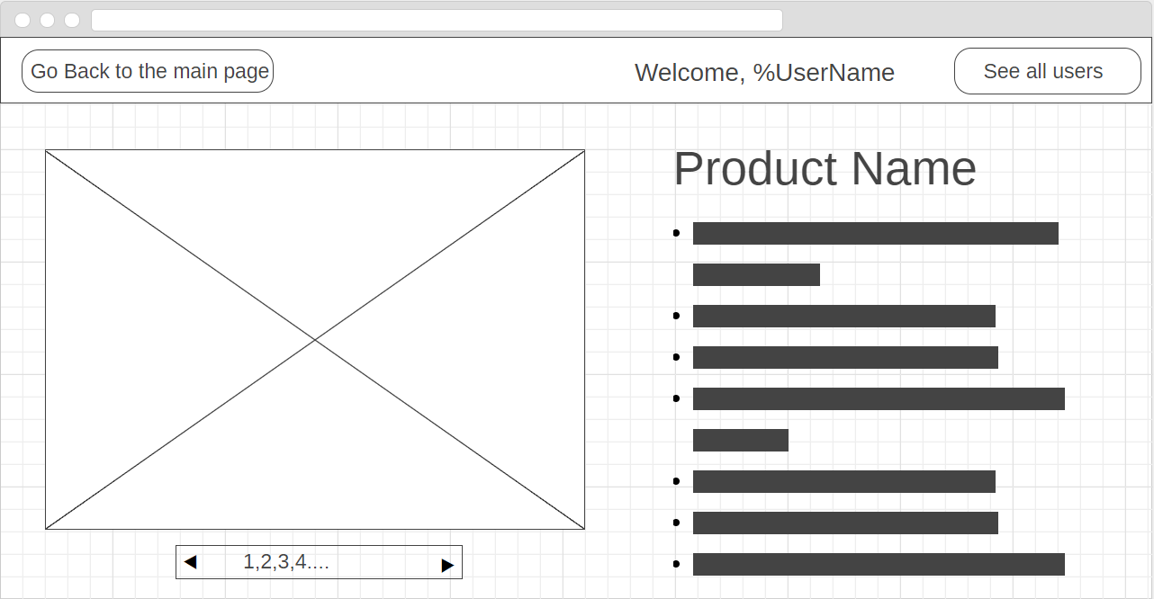

**Product Listing Page example**

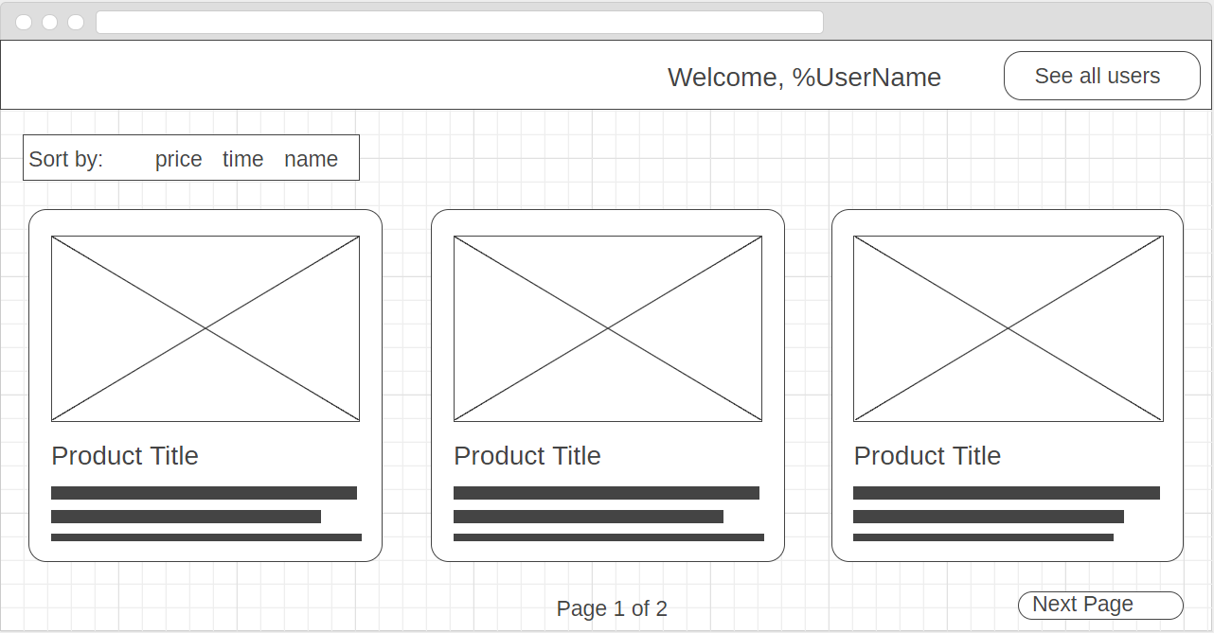

**Login page example**

